**CISM vs. Other Security Certifications: What Makes It Unique?**

In today’s ever-evolving cybersecurity landscape, organizations are constantly seeking professionals with advanced skills to protect their data and infrastructure. Among the plethora of security certifications available, the **Certified Information Security Manager (CISM)** stands out as a highly sought-after credential for those aspiring to lead and manage information security programs. But what makes[**CISM Certification**](https://www.novelvista.com/in/isaca-cism-certification-training)distinct from other popular certifications like CISSP, CISA, or CompTIA Security+? Let’s explore how CISM differentiates itself and why it might be the right choice for your career.

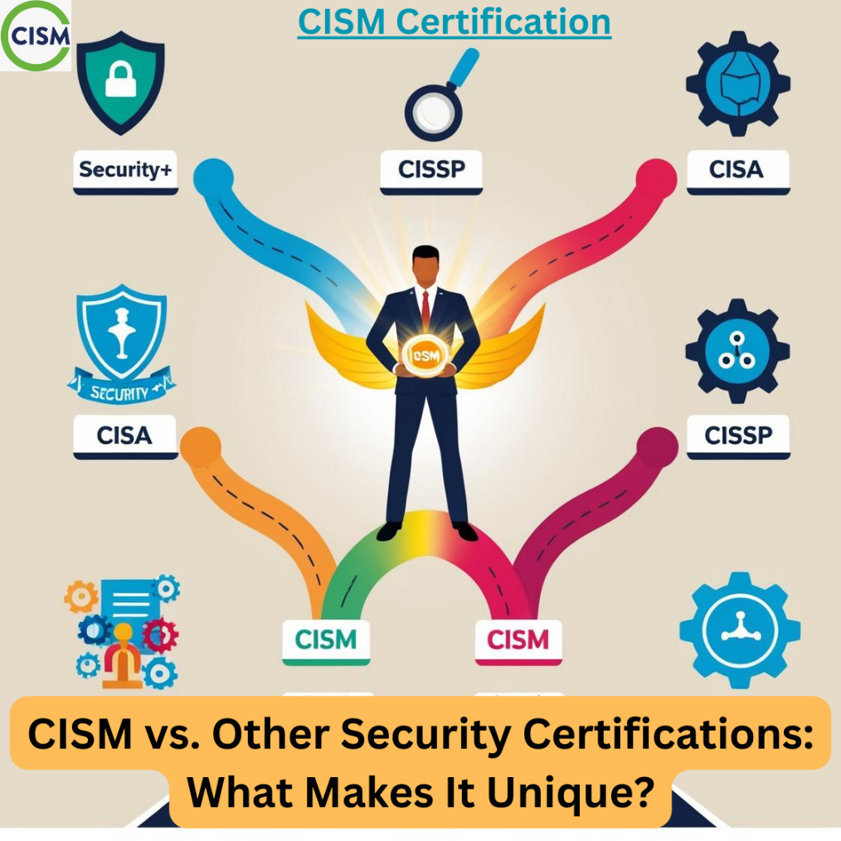

**Understanding CISM: An Overview**

Administered by ISACA, CISM is specifically designed for professionals focused on the **management of enterprise information security**. It emphasizes governance, risk management, compliance, and strategy rather than hands-on technical skills. This makes it ideal for mid-to-senior-level professionals aiming for roles such as information security manager, risk consultant, or CISO.

CISM validates expertise across four critical domains:

1. **Information Security Governance:** Aligning security initiatives with business goals.
2. **Risk Management:** Identifying, analyzing, and mitigating risks.
3. **Information Security Program Development and Management:** Designing and overseeing security programs.
4. **Incident Management:** Managing and responding to security incidents.

**CISM vs. CISSP: Management vs. Technical Depth**

One of the most common comparisons is between **CISM** and the **Certified Information Systems Security Professional (CISSP)**, offered by (ISC)². While both certifications are highly regarded, they cater to different professional profiles.

* **CISM:** Focuses on **leadership and strategy**. It’s tailored for those managing security teams, policies, and compliance at an enterprise level.
* **CISSP:** A broader, more **technical certification**, covering topics like cryptography, security architecture, and network security. It’s often seen as ideal for hands-on practitioners such as security engineers or analysts.

In short, if your career goal involves overseeing security programs and aligning them with business objectives, CISM is the way to go. Conversely, CISSP suits those looking to excel in deeply technical roles.

**CISM vs. CISA: Security vs. Audit**

Another popular ISACA certification, the **Certified Information Systems Auditor (CISA)**, focuses on auditing, control, and assurance. While CISM and CISA share some overlap, their core purposes differ significantly.

* **CISM:** Prioritizes **building and managing security frameworks** to protect an organization’s assets.
* **CISA:** Centers on **evaluating and ensuring the effectiveness of those frameworks** through audits.

Professionals working in **security management** gravitate toward CISM, whereas those in **compliance and auditing** often pursue CISA.

**CISM vs. CompTIA Security+: A Question of Experience**

The **CompTIA Security+** certification is often considered a foundational credential for cybersecurity professionals. It covers basic concepts in risk management, network security, and cryptography. While Security+ provides an excellent entry point into the field, CISM is a much more advanced certification tailored for experienced professionals with at least **five years of work experience** in information security management.

In essence:

* **Security+:** Ideal for beginners seeking a technical grounding in cybersecurity.
* **CISM:** Designed for those looking to step into leadership roles.

**CISM vs. CRISC: Security vs. Risk Management**

The **Certified in Risk and Information Systems Control (CRISC)** certification, another ISACA offering, often overlaps with CISM when it comes to risk management. However, their primary focus areas differ:

* **CISM:** Encompasses a broader scope, including governance, program development, and incident management, in addition to risk management.
* **CRISC:** Specializes in **enterprise risk management and mitigation**, making it ideal for roles like risk manager or business continuity specialist.

If your career aligns more with security leadership, CISM is a better fit. For risk-centric roles, CRISC may be the superior option.

**Why Choose CISM? The Unique Edge**

1. What truly sets the [**CISM course**](https://www.novelvista.com/in/isaca-cism-certification-training) apart is its emphasis on bridging the gap between technical cybersecurity measures and business strategy. Here’s why CISM is unique:

1. **Business Alignment:** Unlike purely technical certifications, CISM ensures that security practices are aligned with an organization’s broader goals, making it invaluable for decision-makers.
2. **Global Recognition:** With ISACA’s strong reputation, CISM is recognized worldwide, especially in industries like finance, healthcare, and technology.
3. **Leadership-Centric Approach:** The certification prepares professionals to lead teams, manage budgets, and communicate effectively with stakeholders.
4. **Focus on Risk Management:** Risk management is central to CISM, a vital skill for today’s threat landscape where risks must be proactively identified and mitigated.
5. **High Demand for CISM Holders:** Many organizations prioritize hiring CISM-certified professionals for roles like **CISO** and **security program manager**, as it demonstrates a blend of technical understanding and business acumen.

**When to Choose CISM Over Other Certifications**

CISM is ideal if you:

* Have significant experience in cybersecurity and want to transition to a **management or leadership role**.
* Are interested in **policy creation**, **risk management**, or **strategic planning**.
* Aim to work closely with C-suite executives and board members to shape security strategies.

If you prefer a hands-on technical role or are new to cybersecurity, certifications like **CISSP** or **Security+** might be more appropriate as a starting point.

**Conclusion**

Choosing the right certification is a pivotal step in shaping your cybersecurity career. While there are several excellent certifications available, **CISM’s focus on leadership, risk management, and business alignment** makes it a standout choice for professionals aspiring to lead security teams and align security programs with organizational objectives.

Ultimately, the best certification for you depends on your career goals, experience, and the type of role you envision. If you’re aiming for a managerial path with a focus on strategy and governance, CISM could be the key to unlocking your potential.

**Advance Your Career with CISM Certification!**

Are you ready to stand out in the competitive world of cybersecurity? The **Certified Information Security Manager (CISM)** certification is your gateway to mastering the art of managing and leading top-notch information security programs.

**Why Choose CISM?**

* Tailored for leaders: Focused on managing and strategizing security, unlike CISSP or CompTIA Security+.
* Globally recognized: Preferred by employers worldwide for its leadership emphasis.
* Career growth: Unlock high-paying roles in information security management.

**Take charge of your future!**  
Explore how CISM sets you apart in the cybersecurity landscape. Gain the expertise to protect critical data and infrastructure with confidence.

**Enroll today and elevate your career!**  
For more details, contact: 76786 42503

Visit: <https://www.novelvista.com/in/isaca-cism-certification-training>